**תרגיל בית 7**

**שם: אסלאם גיגיני**

**שאלה 1:**

**HTML:**

<!DOCTYPE html>

<html lang="en">

<head>

<meta charset="UTF-8">

<meta name="viewport" content="width=device-width, initial-scale=1.0">

<title>Document</title>

<link href="/normalize/normalize.css" rel="stylesheet">

<link rel="stylesheet" href="style.css">

</head>

<body>

<form action="https://formspree.io/f/xldbakje" method="post">

<div class="container">

<h2>Please sign in</h1>

<input type="email" placeholder="Email adddress" class="username" autofocus>

<input type="password" placeholder="Password" class="password">

<label for="remember">

<input type="checkbox" class="remember-me" name="remember">

Remember me

</label>

<button class="Sign-in">Sign in</button>

<p class="copy-right">Copyrights &copy; 2025</p>

</div>

</form>

</body>

</html>

**CSS:**

body{

background-color: #f5f5f5;

font-family: sans-serif;

display: flex;

flex-direction: column;

align-items: center;

margin: 0;

}

.container{

width: 50vw;

height: 50vh;

display: flex;

flex-direction: column;

justify-content: center;

align-items: center;

gap: 10px;

}

.username, .password{

height: 3.5rem;

width: 20rem;

border-color: #ced4da;

box-sizing: border-box;

padding-left: 3%;

}

.username:focus, .password:focus{

border-color: #86b7fe;

box-shadow: #b9d3fa;

}

.Sign-in{

height: 3.5rem;

width: 20rem;

background-color: #0d6efd;

border-radius: 40px;

border: none;

}

.Sign-in:hover{

background-color: #0b5ed7;

}

**ScreenShot:**

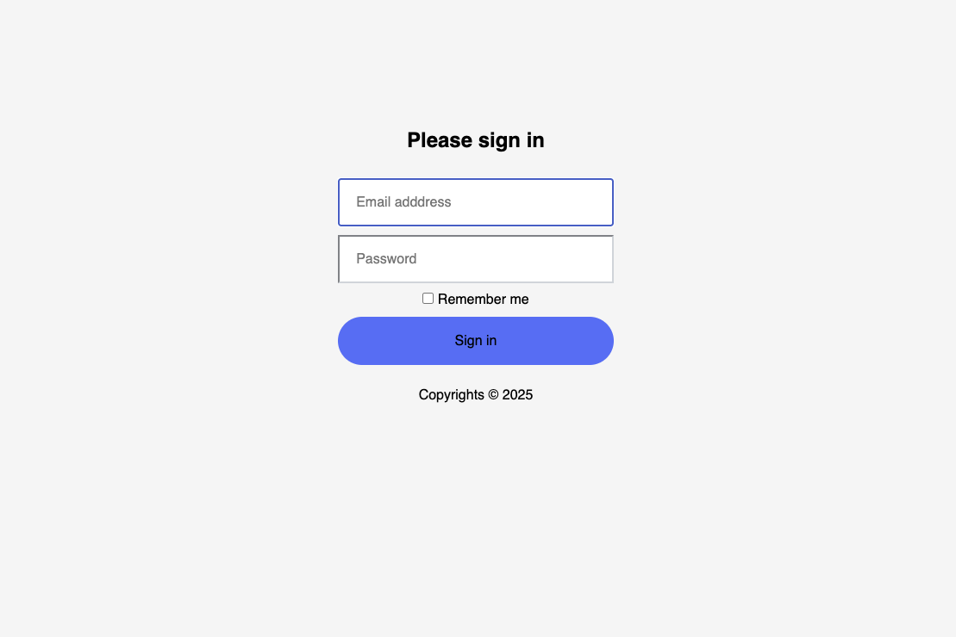

**שאלה 2:**

**HTML:**

<!DOCTYPE html>

<html lang="en">

<head>

<meta charset="UTF-8">

<meta name="viewport" content="width=device-width, initial-scale=1.0">

<title>Document</title>

<link rel="stylesheet" href="/normalize/normalize.css">

<link rel="stylesheet" href="style.css">

</head>

<body>

<div class="container">

<div class="menu">

<link href="" class="page">About

</div>

<div class="menu">

<link href="" class="page">Courses

</div>

<div class="menu">

<link href="" class="page" >Forum

</div>

<div class="menu">

<link href="" class="page">Learning Paths

</div>

<div class="menu">

<link href="" class="page">Contact

</div>

</div>

</body>

</html>

**CSS:**

body{

font-family: sans-serif;

}

.container{

display: flex;

border: 5px solid black;

color:white;

height: 99vh;

flex-direction: column;

text-align: center;

}

.menu{

background-color: black;

padding: 0.25rem;

}

@media screen and (min-width:768px){

.container{

flex-direction: row;

justify-content: flex-end;

height: fit-content;

background-color: black;

}

}

**ScreenShot:**

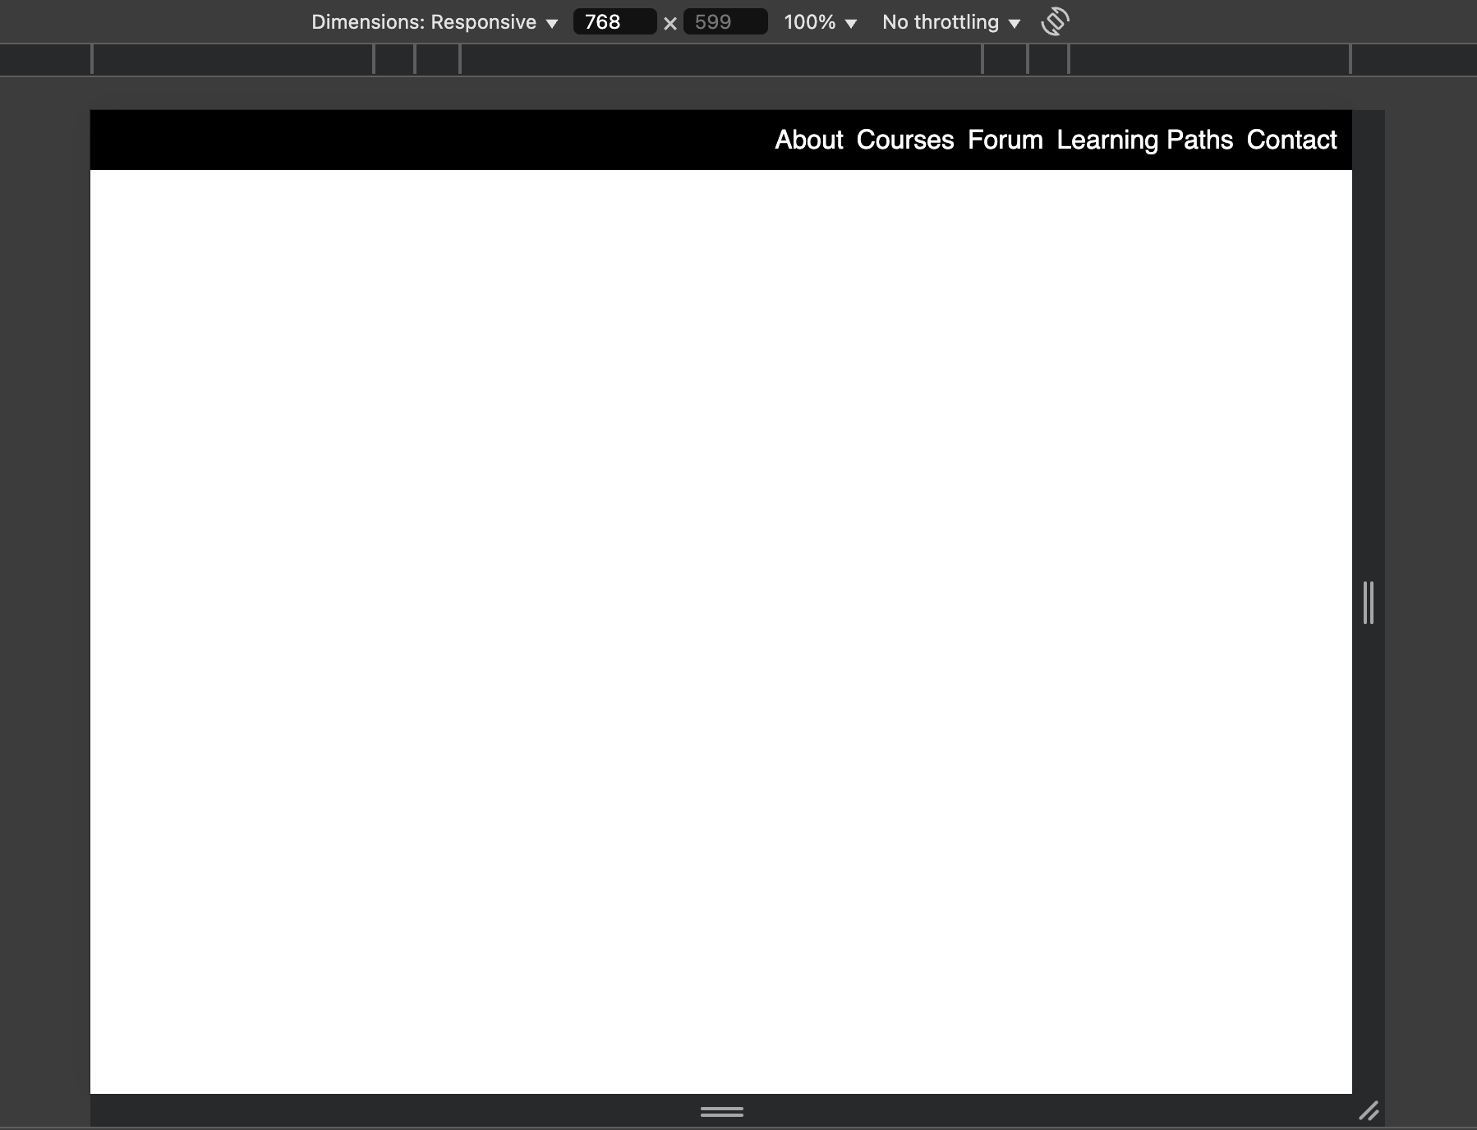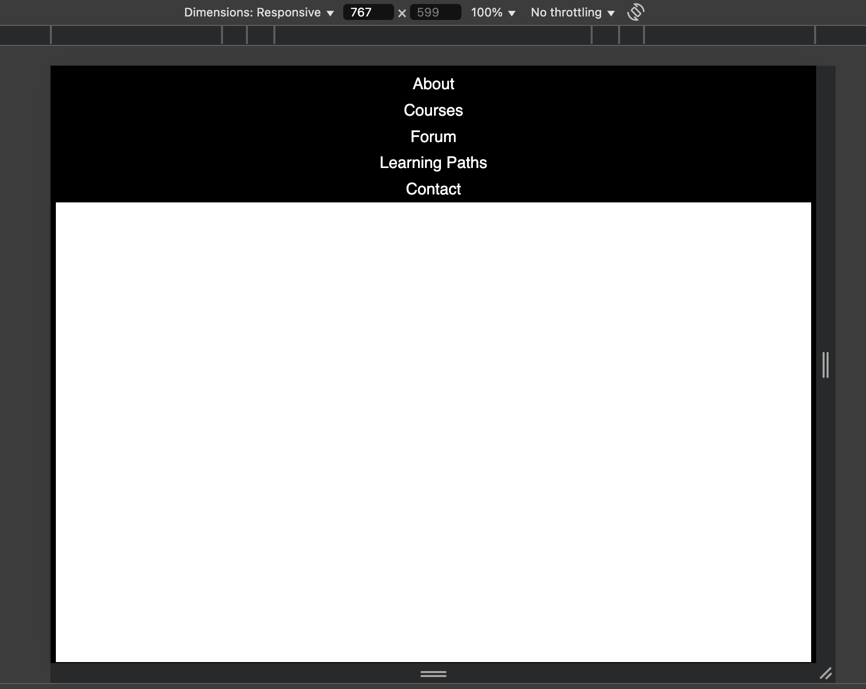

**שאלה 3:**

**HTML:**

<!DOCTYPE html>

<html lang="en">

<head>

<meta charset="UTF-8">

<meta name="viewport" content="width=device-width, initial-scale=1.0">

<title>Document</title>

<link rel="stylesheet" href="/normalize/normalize.css">

<link rel="stylesheet" href="style.css">

</head>

<body>

<div class="container">

<img src="/lib/images/strawberry.jpeg" alt="Strawberry">

<img src="/lib/images/grapes.jpeg" alt="Grapes">

<img src="/lib/images/img-3.jpeg" alt="Image 3">

<img src="/lib/images/img-4.jpeg" alt="Image 4">

<img src="/lib/images/img-5.jpeg" alt="Image 5">

<img src="/lib/images/img-6.jpeg" alt="Image 6">

<img src="/lib/images/img-7.jpeg" alt="Image 7">

<img src="/lib/images/img-8.jpeg" alt="Image 8">

<img src="/lib/images/img-9.jpeg" alt="Image 9">

</div>

</body>

</html>

**CSS:**

.container{

display: grid;

height: 90vh;

gap: 10px;

grid-template-rows: repeat(9,1fr);

justify-content: center;

margin: 0 10px;

}

img{

width: 100%;

object-fit: cover;

}

@media screen and (max-width: 1024px) and (min-width: 768px){

.container{

grid-template-rows: repeat(5,1fr);

grid-template-columns: repeat(2,1fr);

}

}

@media screen and (min-width: 1024px){

.container{

grid-template-rows: repeat(4,1fr);

grid-template-columns: repeat(3,1fr);

margin-top: 10px;

}

img:nth-of-type(3){

grid-column: 2 / span 2;

grid-row: 1 / span 2;

}

}

**ScreenShot:**

